**COMPUTER SCIENCE FUNDAMENTALS AND CARRIER PATHWAYS**

**ASSIGNMENT TITLE:** **Linux Assignment**

**NAME: Chandra Prakash Mishra**

**COURSE: BTech CSE Core (Semester -1)**

**SECTION:** A

**SCHOOL: School of Engineering and Technology**

**TOPIC NAME: Linux ( Assignment no-3)**

**TEACHER’S NAME: Mr. Rajesh Kumar**

**#INTRODUCTION**

This assignment is designed to provide practical, hands -on experience with the Linux Operating System. Linux is an essential skill for computer science and IT professionals due to its inherent flexibility, security, and powerful scripting capabilities. The core objective is to demonstrate proficiency across three key areas:

1) Successfully establishing a Linux environment (Installation)

2) Executing and documenting fundamental shell commands

3) Developing functional Bash shell scripts to automate system administration tasks **How to download** **Ubuntu and virtual box and make a machine to operate Linux**

**#STEPS TO INSTALL**

Step 1: browse download Ubuntu

Step2: Download it in the window according to the system

Step 3: browse download virtual box

Step 4: download it in window

Step 5: open the virtual box manager and click the machine

Step 6: select new machine and create a new machine giving it name as Ubuntu

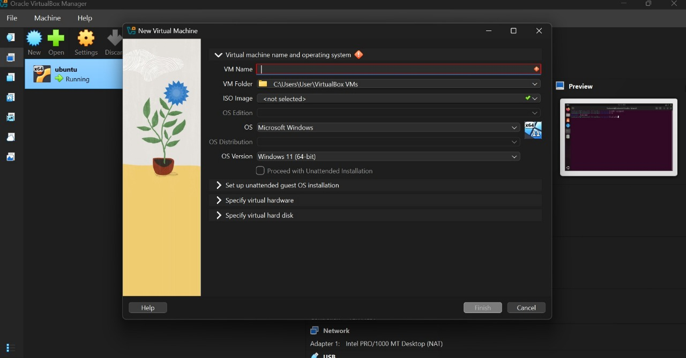

Step 7: click on specify virtual hardware than set up base memory and number and CPUs as follows

Step 8: add a strong password and click on finish than new machine will be created to start that machine click on start.

Step 9: start the machine this would take 20-30 minutes to set up the machine than click and select all the default setting and than start the machine again it will show the interface as follows

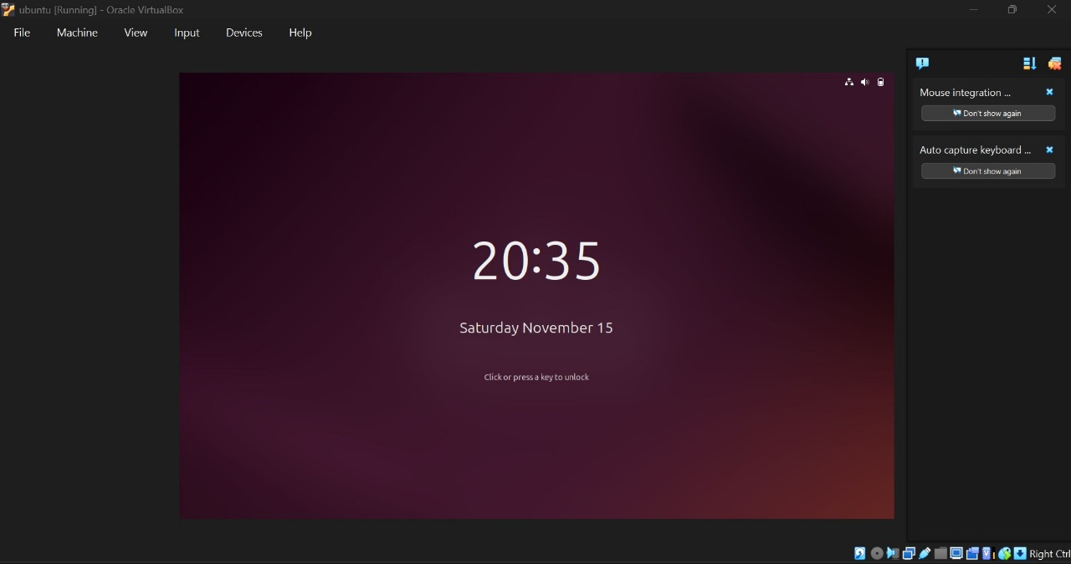

Step 10: add the password that was created in step 8

Step 11: this will appear click on the circle type icon and search terminal and there we can practice all the commands

Step 12: here is the terminal

***# COMMANDS PRACTICE SECTION***

DESCRIPTION :- The “ls” command in Linux is used to list the contents of the directories. When we execute this command without any arguments, it displays the files and subdirectories within the current working directory in alphabetical order.

SYNTAX :- ls [options] [file/directory]

(2) MKDIR

DESCRIPTION :- The command “mkdir” refers to “make directory”. This Linux command is used to create new directories in the file system.

SYNTAX :- mkdir [directory_name]

IMPLEMENTATION :-

3. CD

DESCRIPTION :- The “cd” command in Linux is used to navigate the file system. It allows the user to change the current working directory in the terminal. Here “cd” stands for “change directory”. cd /path Go to the specified folder

SYNTAX :- cd [options] [directory]

IMPLEMENTATION :-

(4) MV

DESCRIPTION :- The word “mv” stands for “move files”. This command in Linux is used to move or rename files and directories.

SYNTAX :- mv [options] source destination

IMPLEMENTATION :-

(5) CAT

DESCRIPTION :- The name “cat” command means “concatenate”. It is used to display the content of files, concatenate multiple files, and redirect output to create or append to files.

SYNTAX :- Viewing file content :- cat [filename]

6. CP

DESCRIPTION :- The name “cp” stands for “copy files”. This command is used to copy files or directories from one location to another.

SYNTAX :- cp [options] source destination

(7) RM

DESCRIPTION :- The name “rm” stands for “remove files”. This command in Linux is used to permanently delete files. With options like -r for recursive deletion and -f for force deletion, it can remove directories and their contents safely and efficiently. SYNTAX :- rm [options] [file]

IMPLEMENTATION :-

(8.) CHMOD

DESCRIPTION :- The “chmod” stands for “change mode”. This command in Linux is used to change the permissions (read, write and execute) of files and directories. These permissions determine who can access or modify the file or directory.

SYNTAX :- chmod [options] mode file

IMPLEMENTATION :-

(9.) PS

DESCRIPTION :- The “ps” command in Linux is used to display information about active processed running on the system. It provides a snapshot view of current processed for the current user or all users depending on options.

SYNTAX :- ps [options]

10(17) TOP

DESCRIPTION :- The “top” command in Linux provides a dynamic, real-time view of running processes and overall system resource usage. It displays system statistics including CPU and memory usage, process information and system load averages. SYNTAX :- top

IMPLEMENTATION :-

(11) PING COMMAND

DESCRIPTION :- The “ping” command is a network utility command used to test the reachability of a host on an IP network and measure the round-trip time for messages sent from the originating host to a destination computer.

SYNTAX :- ping [options] destination

IMPLEMENTATION :-

12. MV COMMAND

Discription:- The word “mv” stands for “move files”. This command in Linux is used to move or rename files and directories.

Syntax:- mv [options] source destination

(13) CLEAR COMMAND

DESCRIPTION :- The “clear” command in Linux is used to clear the terminal screen, removing all previous commands and output from the visible area.

SYNTAX :- clear

IMPLIMENTATION:

(14) HEAD COMMAND

DESCRIPTION :- The “head” command in Linux is used to display the first few lines of a text file directly in the terminal. By default, it shows the first 10 lines but allows customization to show a specific number of lines or bytes.

SYNTAX :- head [options] [files]

15 TAIL COMMAND

DESCRIPTION :- The “tail” command in Linux is used to display the last part of a file, typically the last 10 lines by default. It is commonly used to monitor log files or view recent updates added to files.

SYNTAX :- tail [options] [files]

(16) CHOWN COMMAND

DESCRIPTION :- The “chown” stands for “change owner”. This command is used to change the ownership of files or directories. It allows changing the user (owner) and optionally the group associated with a file or directory.

SYNTAX :- chown [options] new_owner[:new_group] files

(17) TOP COMMAND

DESCRIPTION :- The “top” command in Linux provides a dynamic, real-time view of running processes and overall system resource usage. It displays system statistics including CPU and memory usage, process information and system load averages. SYNTAX :- top

IMPLEMENTATION :-

(18) TOUCH COMMAND

DESCRIPTION :- The ”touch” command in Linux is mainly used to create empty files or update the access and modification timestamps of existing files without changing their content.

SYNTAX :- touch [options] file_name

IMPLEMENTATION :-

(19) WHOAMI

DESCRIPTION :- The “whoami” command in Linux displays the username of the current effective user that is, the username under which the current process is running. This command can run without options also.

SYNTAX :- whoami [options]

(20) PWD

DESCRIPTION :- This command prints the current working directory, that means it tells you that where you are exactly in the file system hierarchy. The “pwd” command in Linux stands for “Print Current Working directory”.

SYNTAX :- pwd

IMPLEMENTATION :-

(21) TREE

DESCRIPTION :- The tree command in Linux displays the directory structure in a clear tree-like format, showing files and subdirectories hierarchically.

SYNTAX :- tree

***SHELL SCRIPT DEVELOPMENT***

***BACKUP A DIRECTORY***

A script that copies a specified directory to a backup folder with a timestamp. The output of the script along with the script itself is shown in the snapshots below :-

**CPU/ MEMORY MONITORING**

A script that logs CPU and memory usage to a file at regular intervals. The output of the script along with the script itself is shown in the snapshots below :-

AUTOMATED DOWNLOAD TASK

A script that downloads a file from the internet using “wget” or “curl” and store it in a predefined directory. The output of the script along with the script itself is shown in the snapshots below :-

While doing this assignment, I got practical experience in using and combining Linux commands inside scripts, which made many jobs easier and faster. I learned how to check arguments, create and manage directories, and handle errors in my scripts. These skills will be very useful for my future studies and work, because scripting is important for any computer professional. I also gained confidence in using the terminal and writing scripts, which will help me with more advanced topics later on.

THANK YOU

